WEEKLY PROJECT REPORT
Project Title: AI-Based GST Compliance Helper for MSMEs using OCR and Automated Reconciliation
Role: Developer
Week: 3
Name: Bhoomika
SRN: R23EF048

1. Objectives for the Week
- To improve OCR accuracy and data extraction reliability
- To implement GST reconciliation logic
- To enhance UI for better visualization of results
- To introduce anomaly detection and alerts

2. Activities Performed
- Improved OCR processing using OpenCV techniques
- Enhanced data extraction using Regex
- Developed reconciliation module to compare invoice data
- Implemented anomaly detection
- Improved UI with status indicators
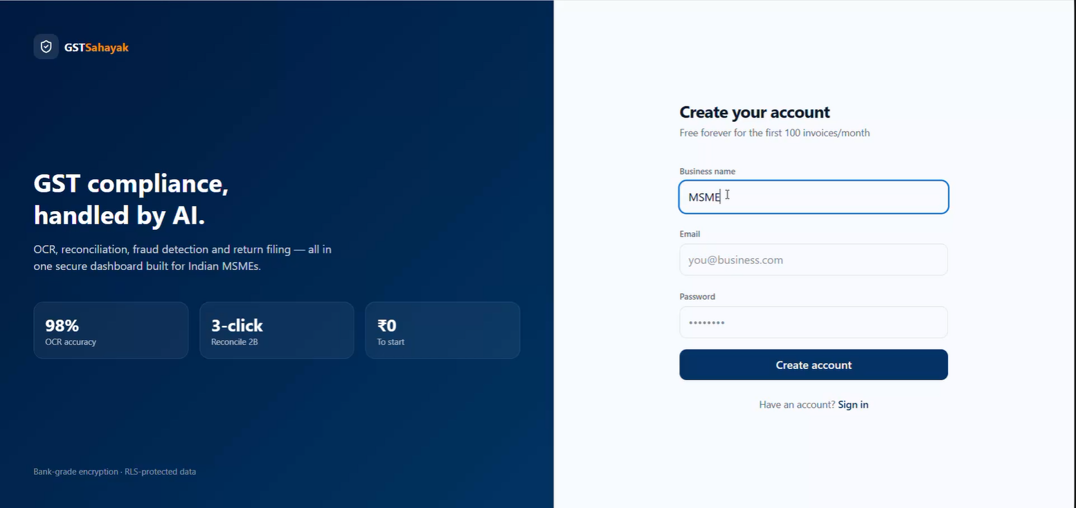
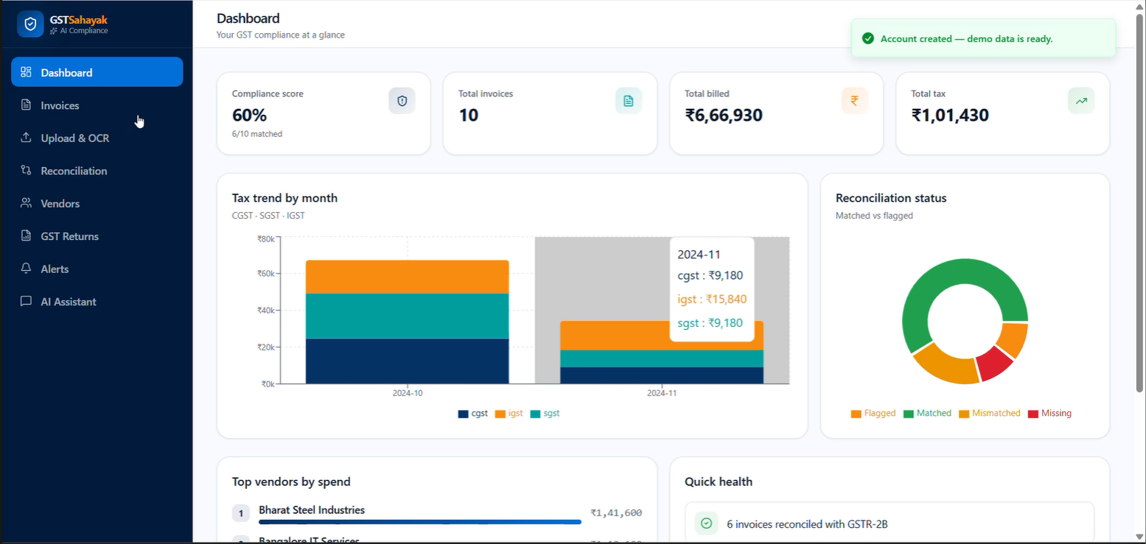

3. Key Design Decisions
- Used structured JSON format
- Modularized OCR and reconciliation logic
- Focused on simple UI design

4. Contribution to Project Development
- Improved OCR and extraction pipeline
- Developed reconciliation logic
- Implemented anomaly detection
- Enhanced UI

5. Challenges Faced
- Handling multiple invoice formats
- OCR inaccuracies
- Data inconsistencies

6. Learning Outcomes
- Learned OCR optimization
- Improved debugging skills
- Understood reconciliation logic

7. Plan for Next Week
- Add chatbot
- Improve fuzzy matching
- Add alert system

8. Conclusion
This week focused on improving accuracy and implementing reconciliation and anomaly detection.

